Name Date
End of Unit 6 test
Vocabulary 1
Put the names of the places into the table depending on whether you use them with or without the.
Himalayas | Africa | Mount Everest | Atlantic Ocean
Sahara Desert | China | United Kingdom | Lake Victoria
Middle East | New Zealand | Antarctica | Amazon

 | With the |  | Without the
0 | the Himalayas | 0 | Africa
1 | the | 6
2 | the | 7
3 | the | 8
4 | the | 9
5 | the | 10

[Total: 10 marks]
Grammar 1
Complete the second sentence so that it has a similar meaning to the first sentence, using the word given.
Do not change the word given.
Use between two and four words, including the word given.
Example:
- Tokyo is very big compared to my town.
much
…………………………………
Tokyo is much bigger than my town.

- The Caribbean Sea is very warm compared to the sea where I live.
lot
The Caribbean Sea is ………………………………… the sea where I live.

- No other river is longer than the River Nile.
the
The River Nile ………………………………… in the world.

- Libya is a little bit smaller than Sudan.
big
Libya is almost ………………………………… Sudan.

- Europe is very small compared to Asia.
much
Asia is ………………………………… Europe.

- It’s more interesting to visit a city than to go to a beach.
as
Going to a beach isn’t ………………………………… visiting a city.
[Total: 5 marks]
Grammar 2
Read the mini dialogues about places.
Choose the best word to complete the sentences.
Circle the correct word.
Example:
- M: Are there any long rivers in your country?

F: Yes, there are several / few.

- F: Has nobody / anyone you know climbed the highest mountain in your country?

M: Yes, my uncle.

- M: Can you speak Hindi?

F: Yes, but only a little / few.

- F: Are there any other mountains in your region?

M: No, these are the only several / ones.

- M: They’ve planted lots of new trees here to help the environment.

F: Yes, but not enough / much.

- F: Do you prefer visiting the countryside or the seaside?

M: I like any / both, actually.

[Total: 5 marks]

Vocabulary 2
Match each animal’s name with its picture.
 | Name of animal | Answer |  |  | Picture
0 | cat | A |  | A | 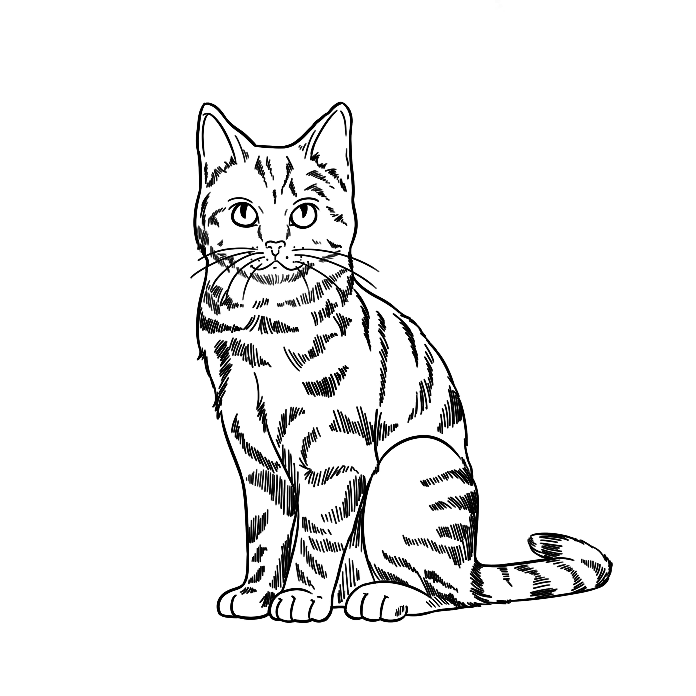  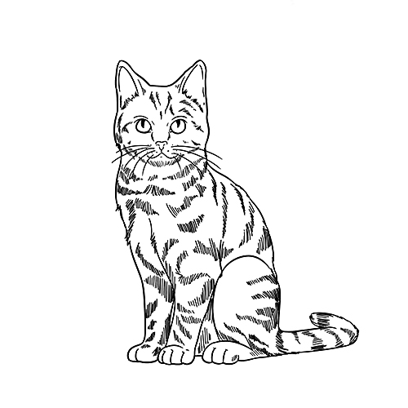
21 | cheetah |  |  | B | 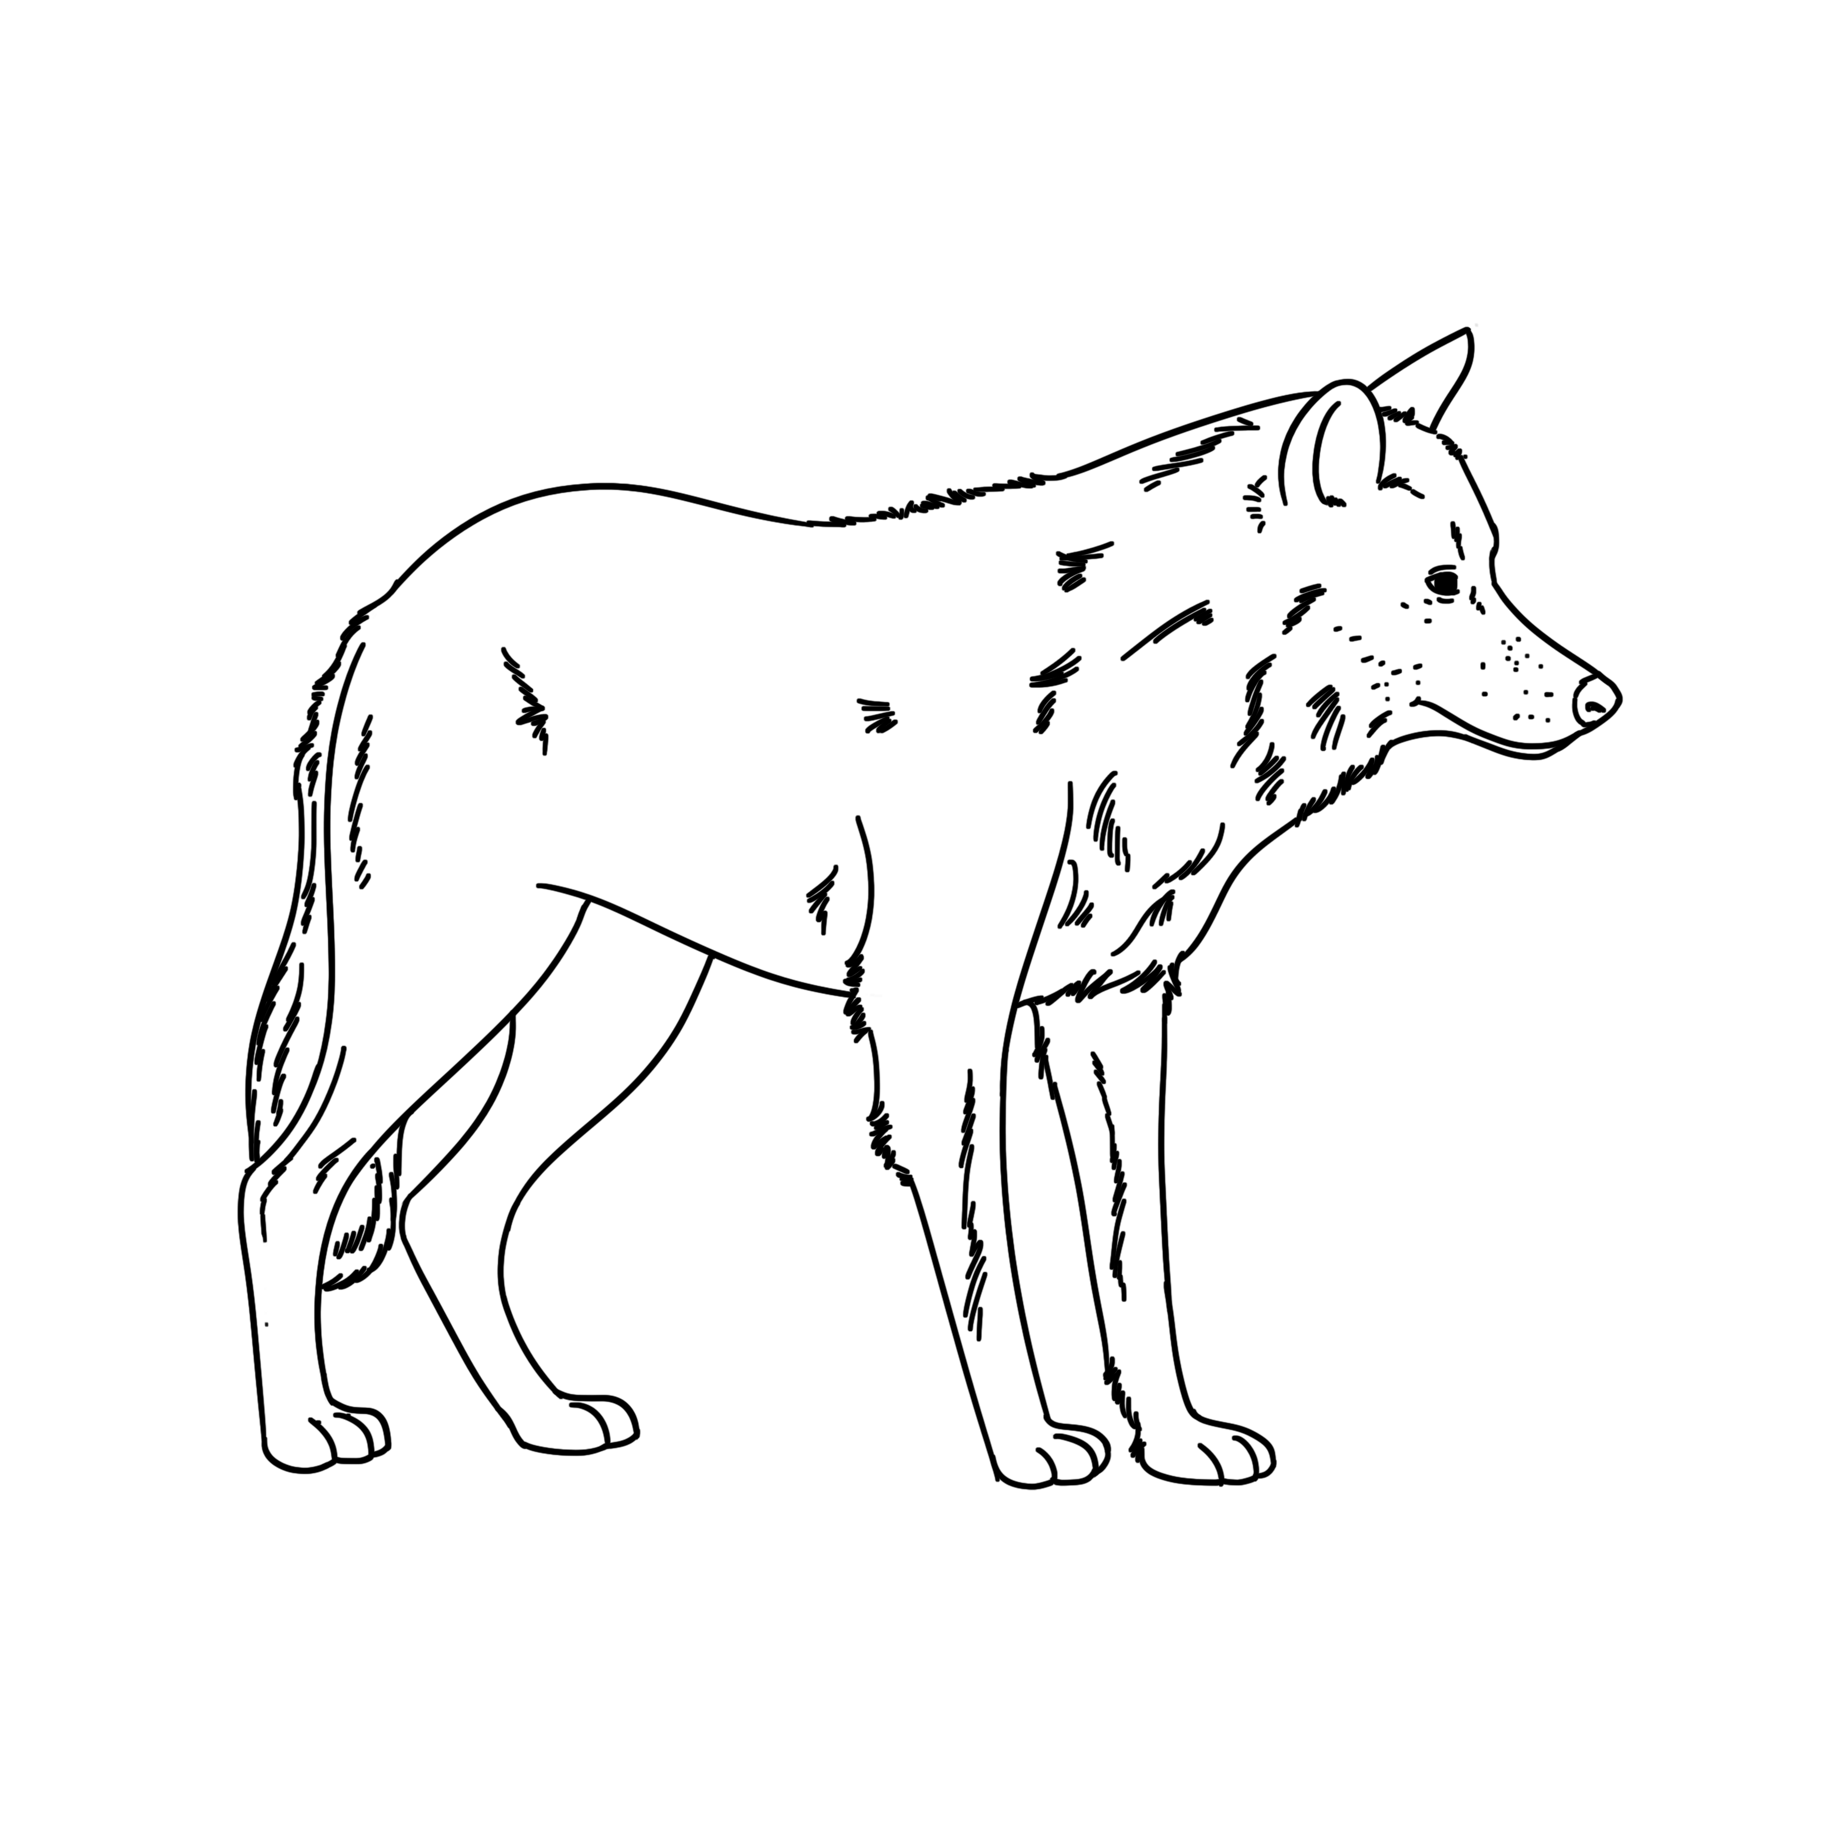
22 | dolphin |  |  | C | 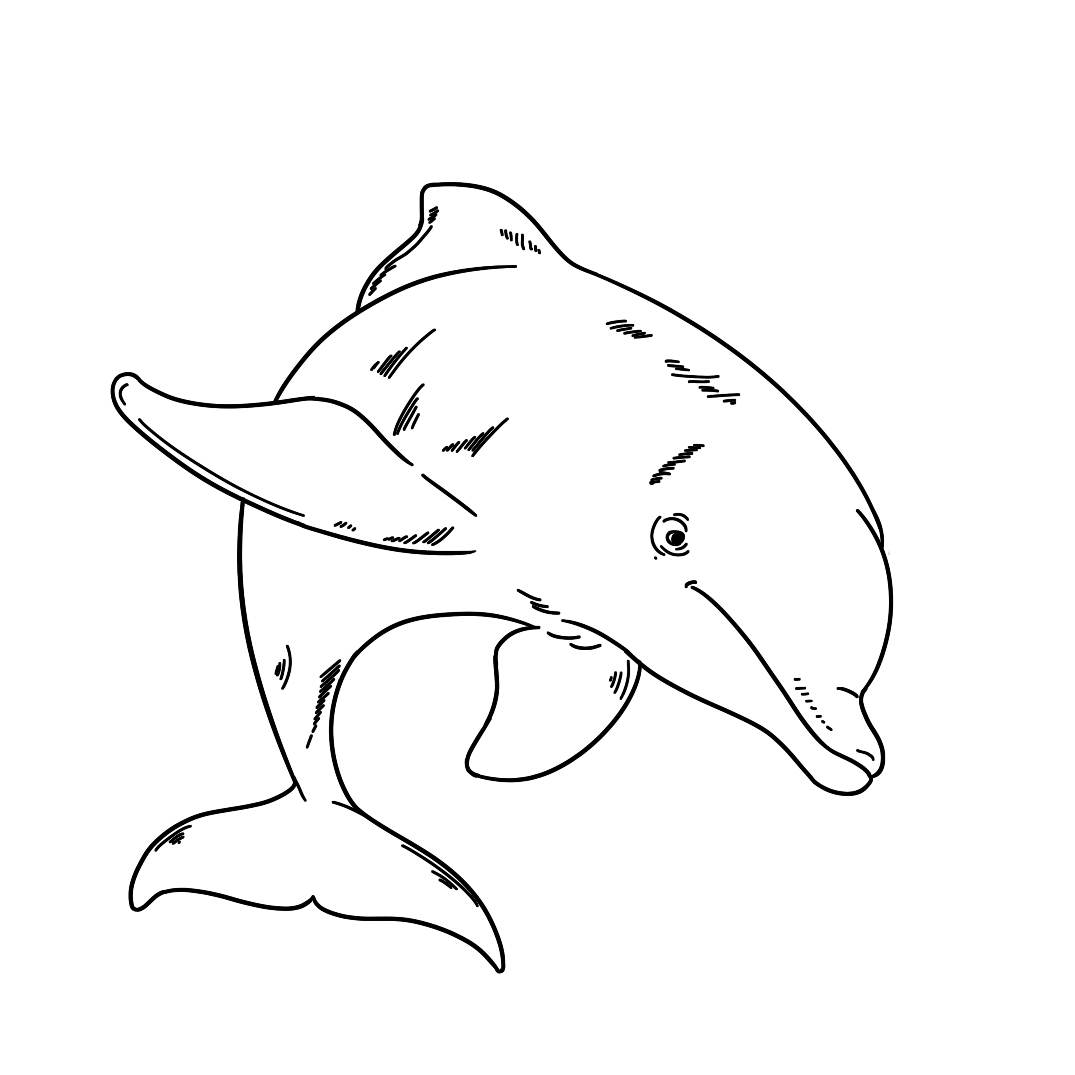
23 | giant tortoise |  |  | D | 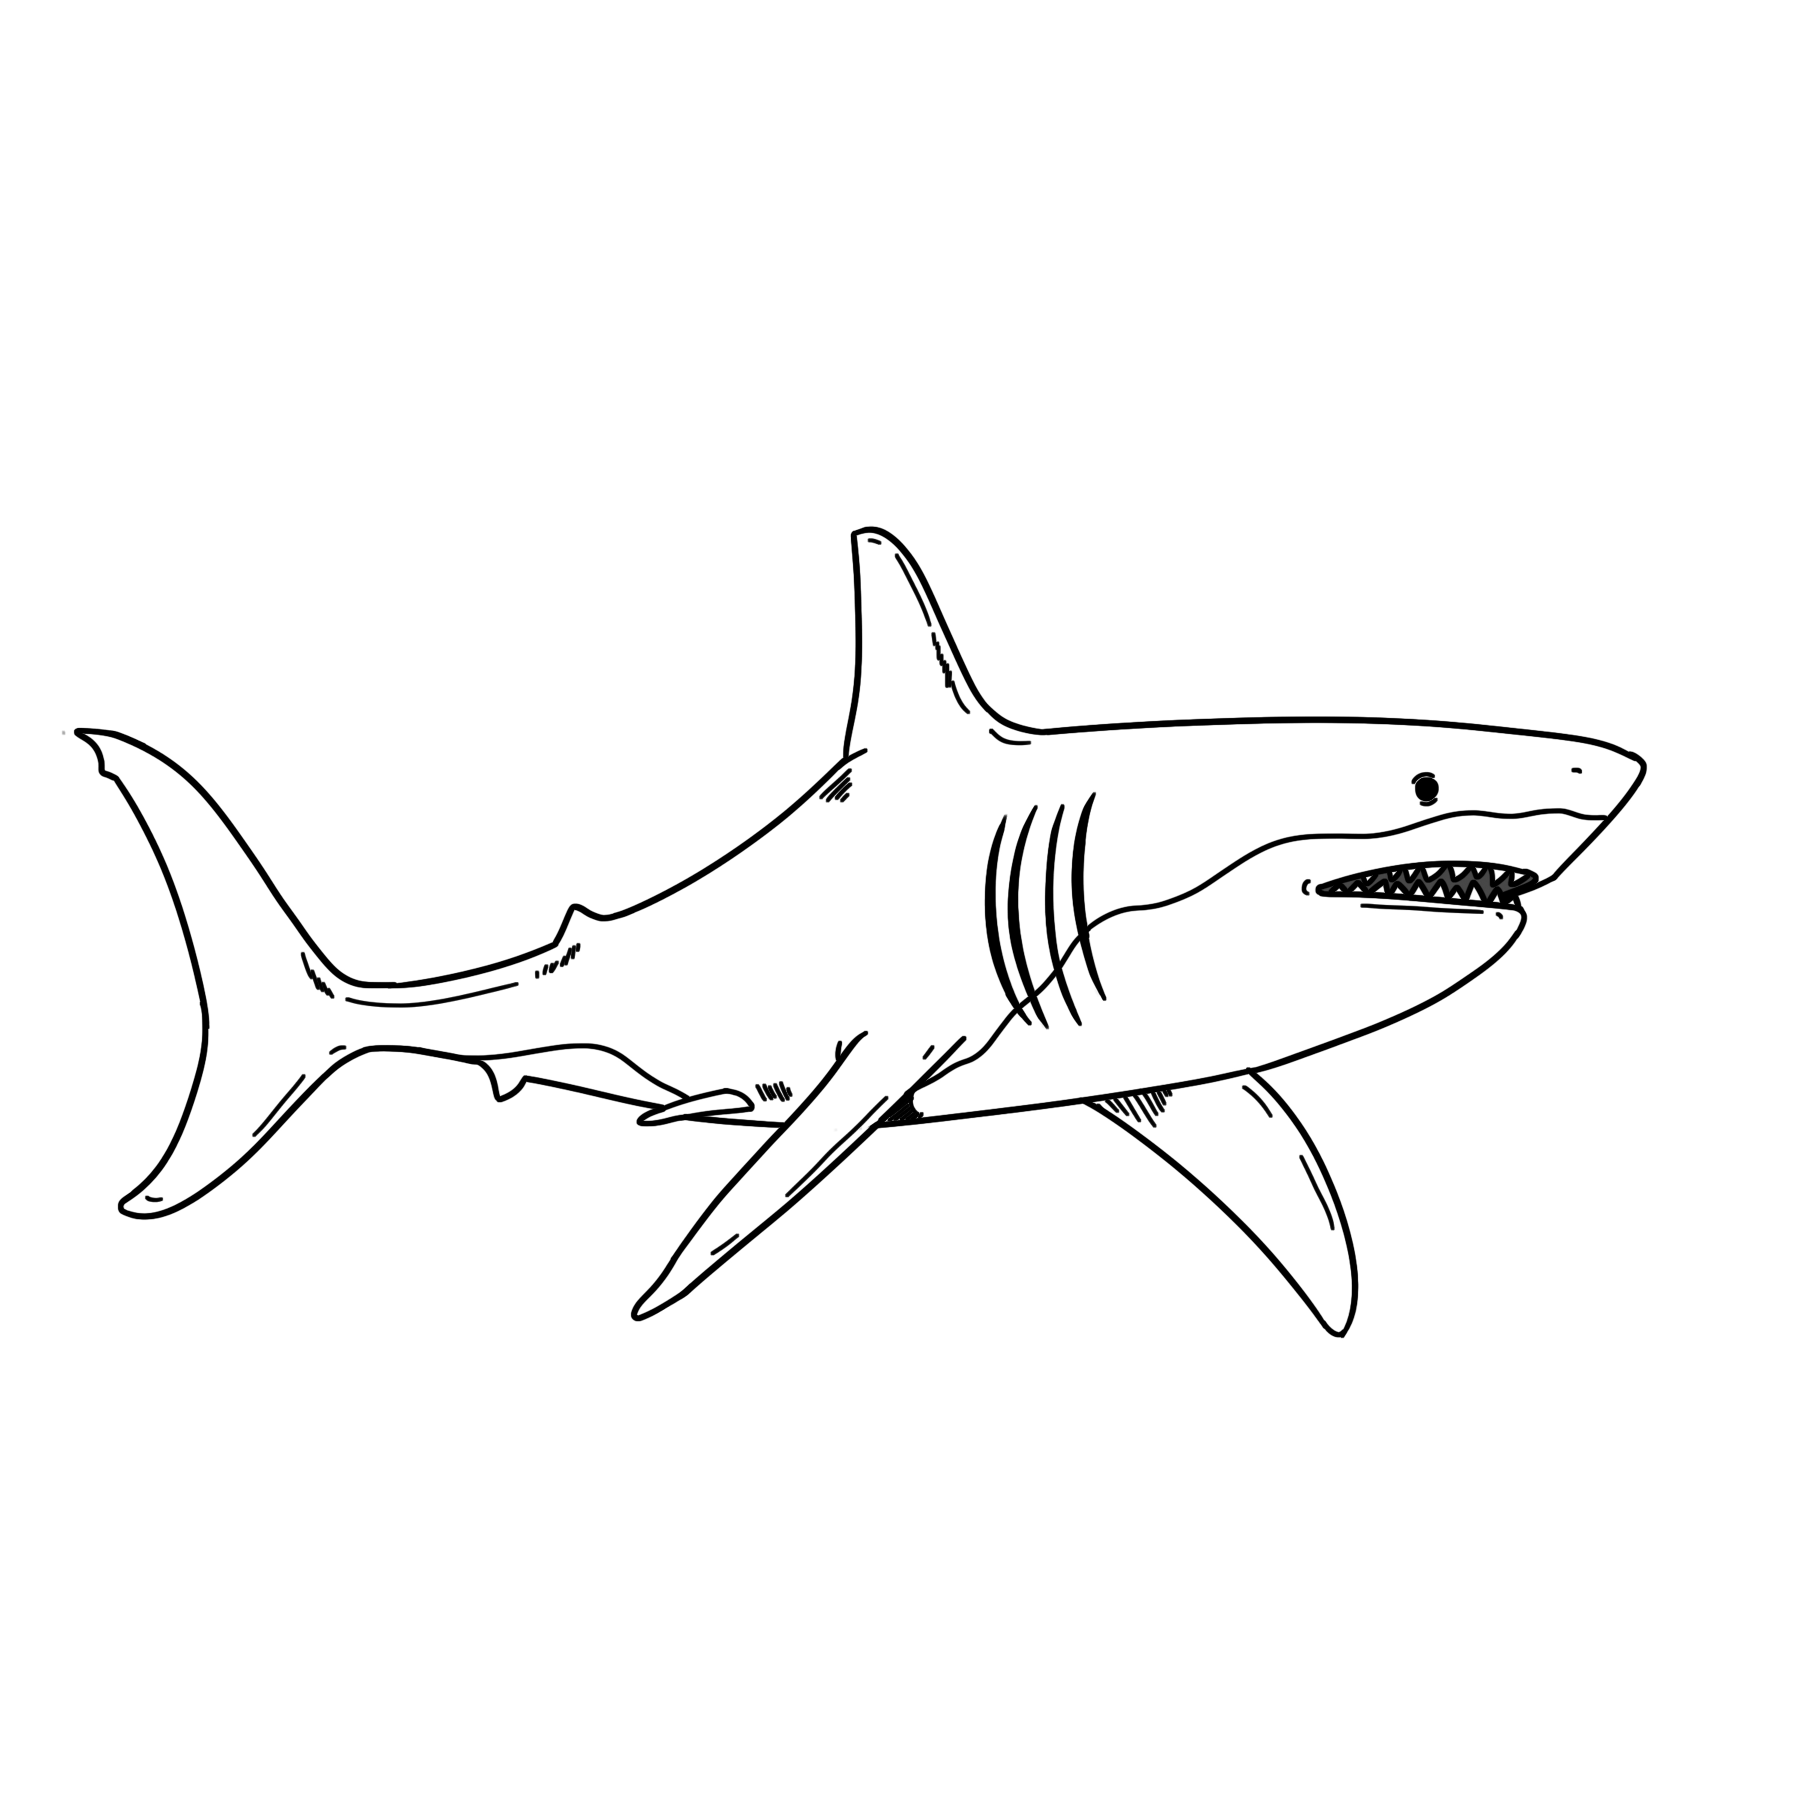
24 | hummingbird |  |  | E | 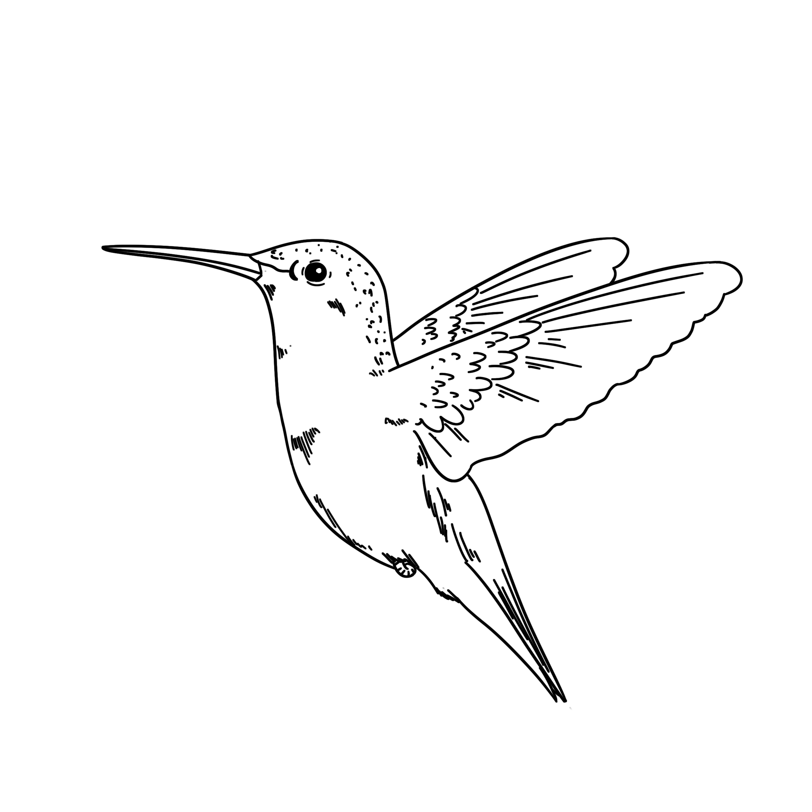
25 | killer whale |  |  | F | 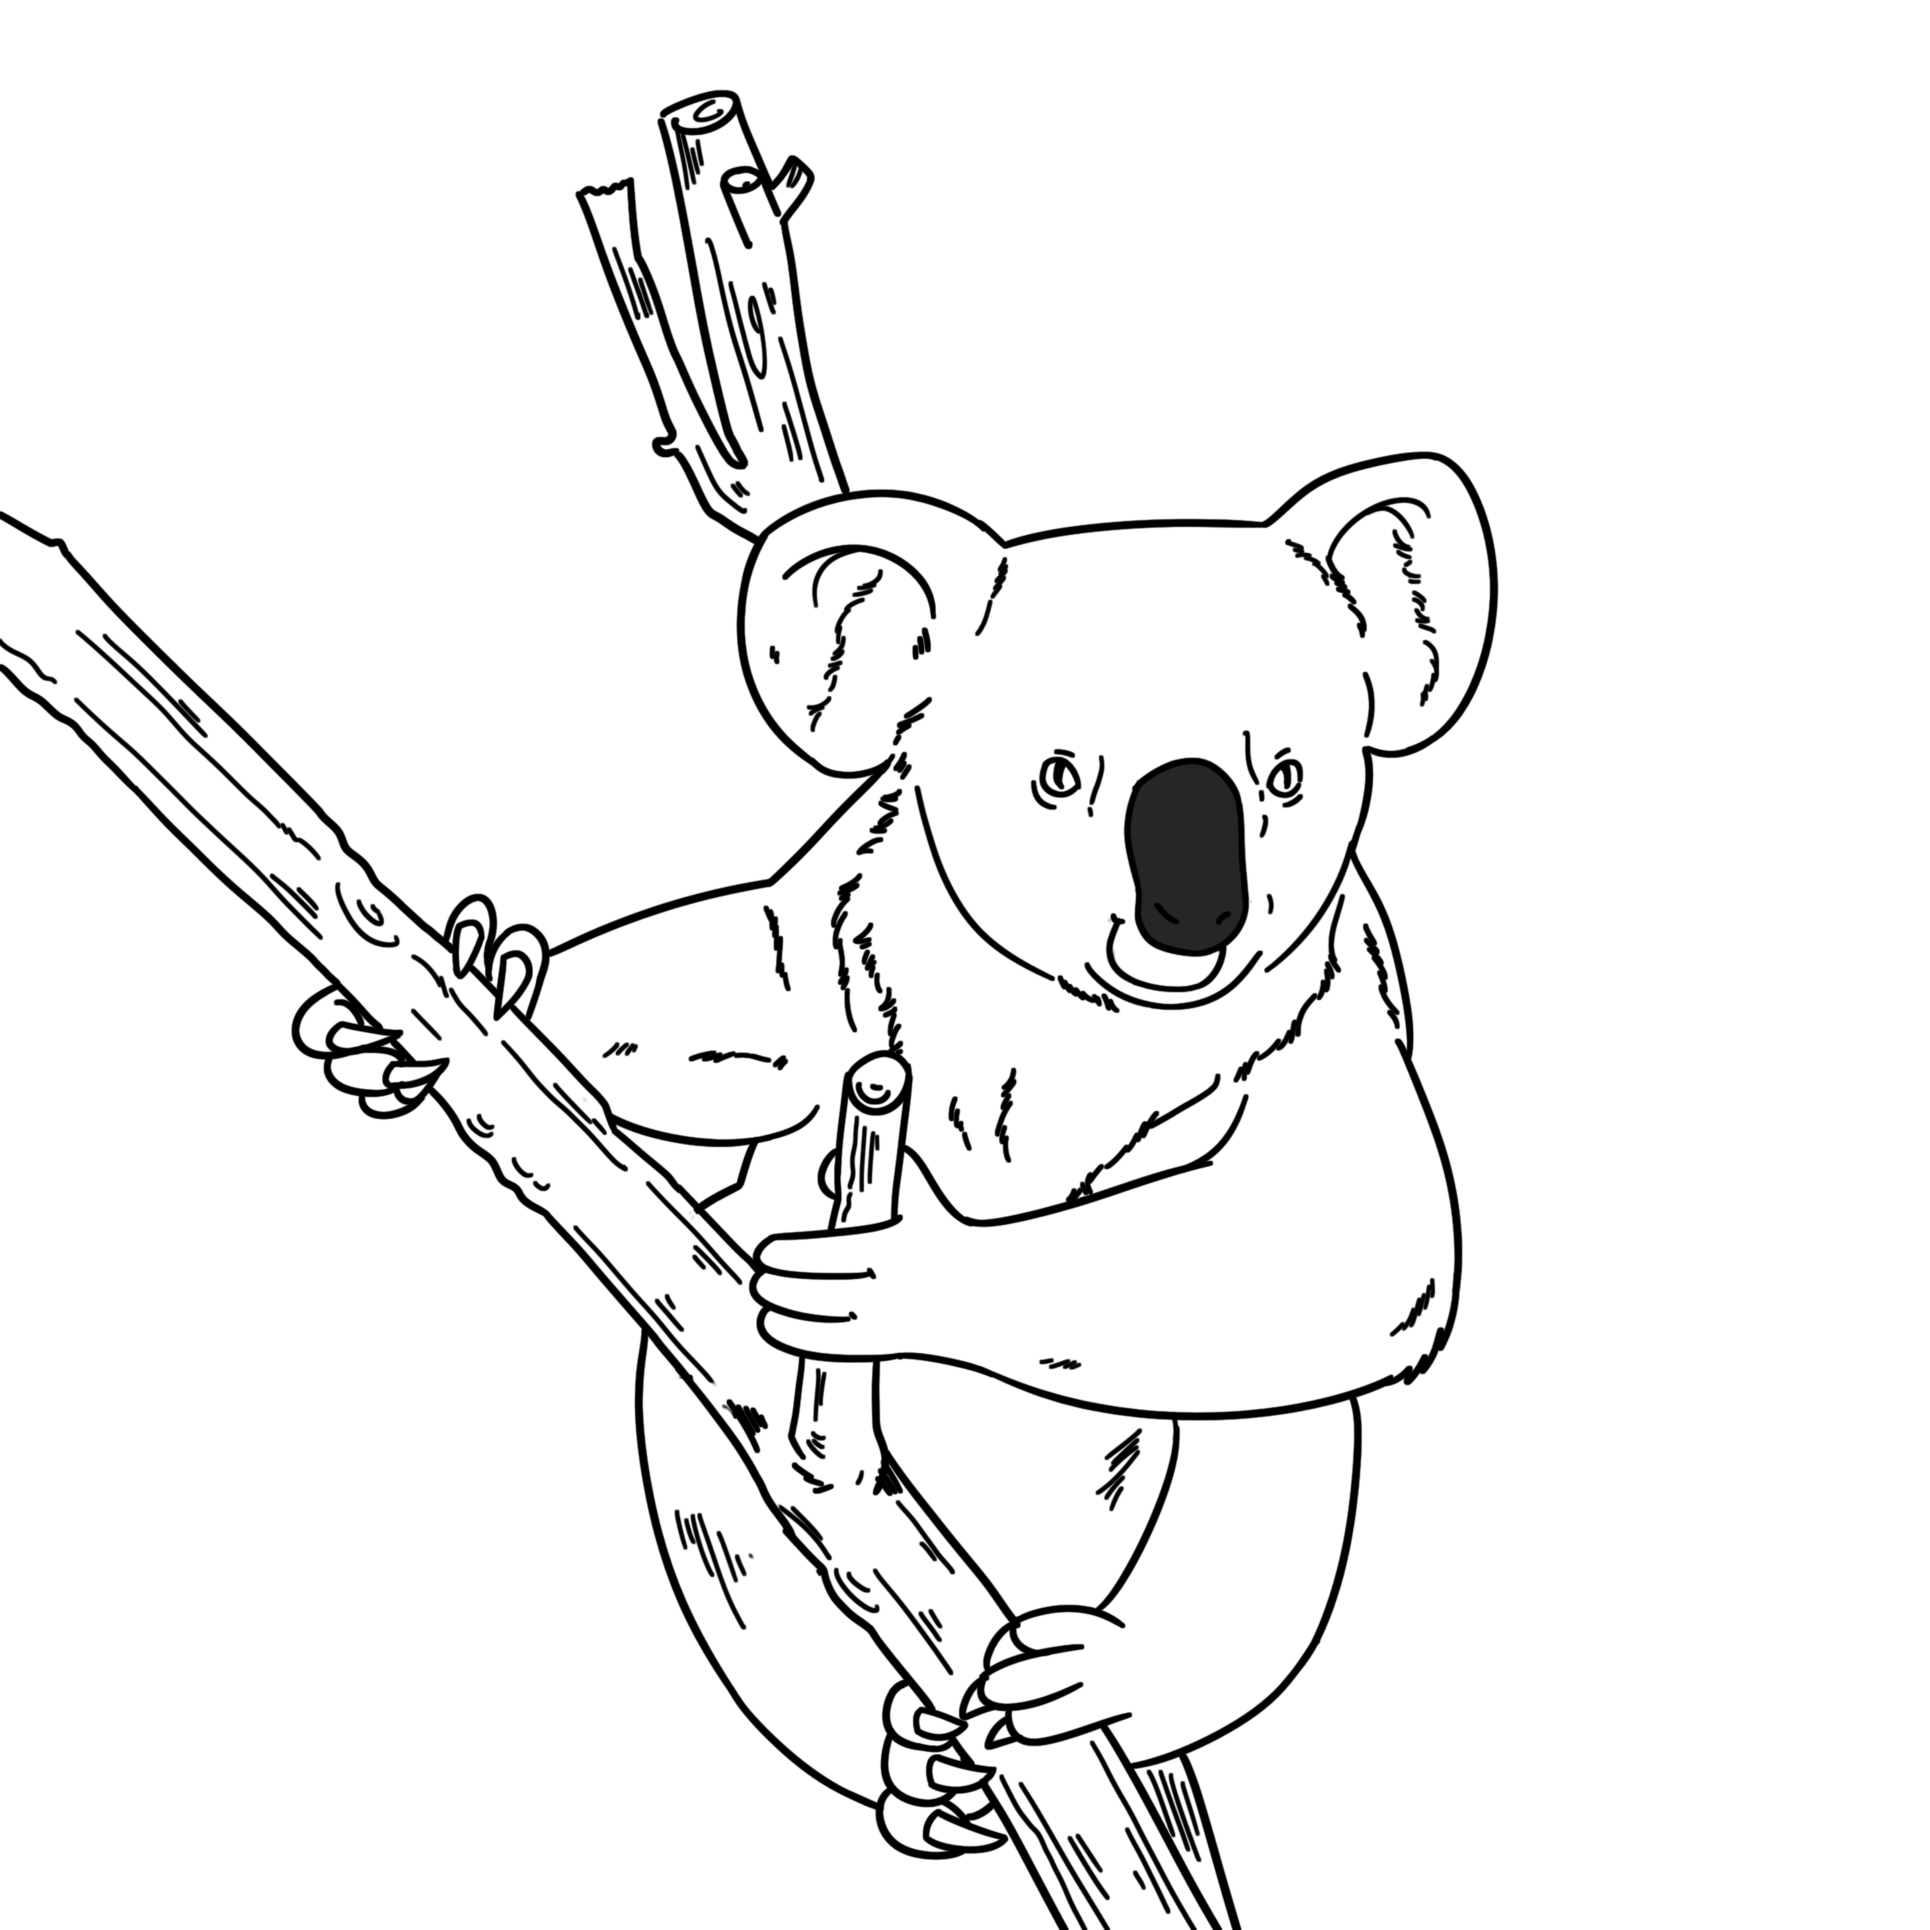
26 | koala bear |  |  | G | 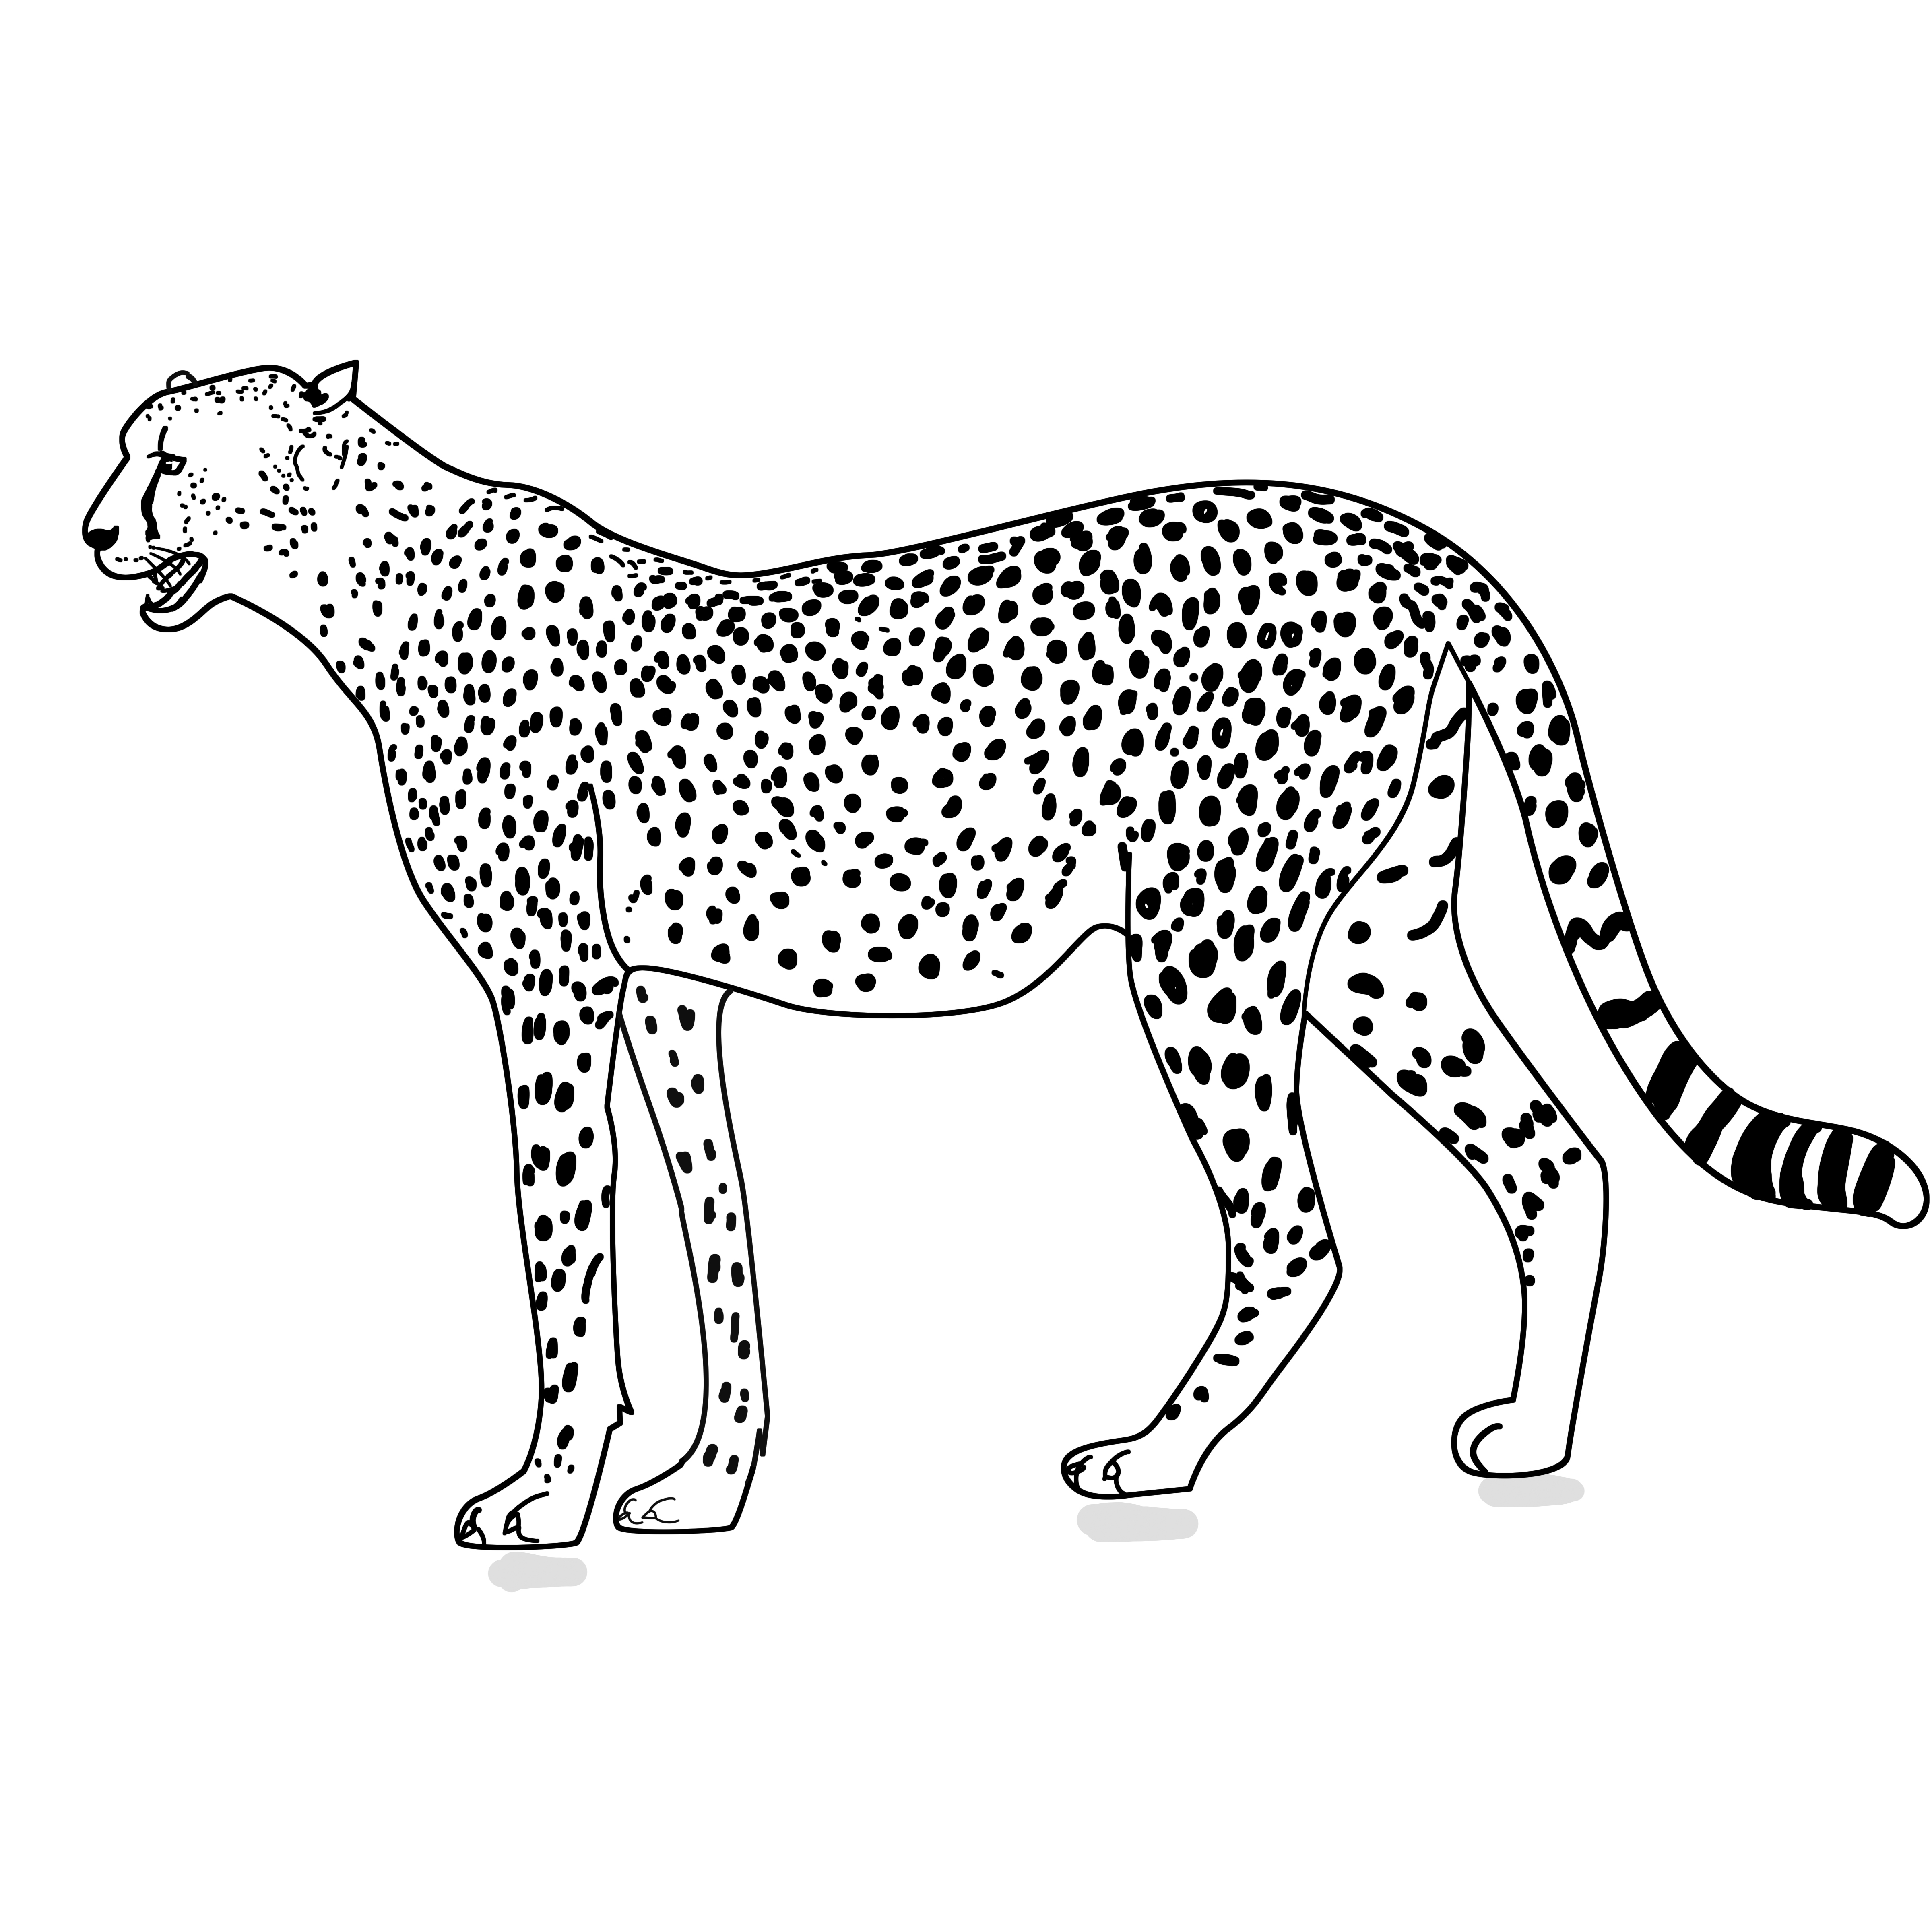
27 | shark |  |  | H | 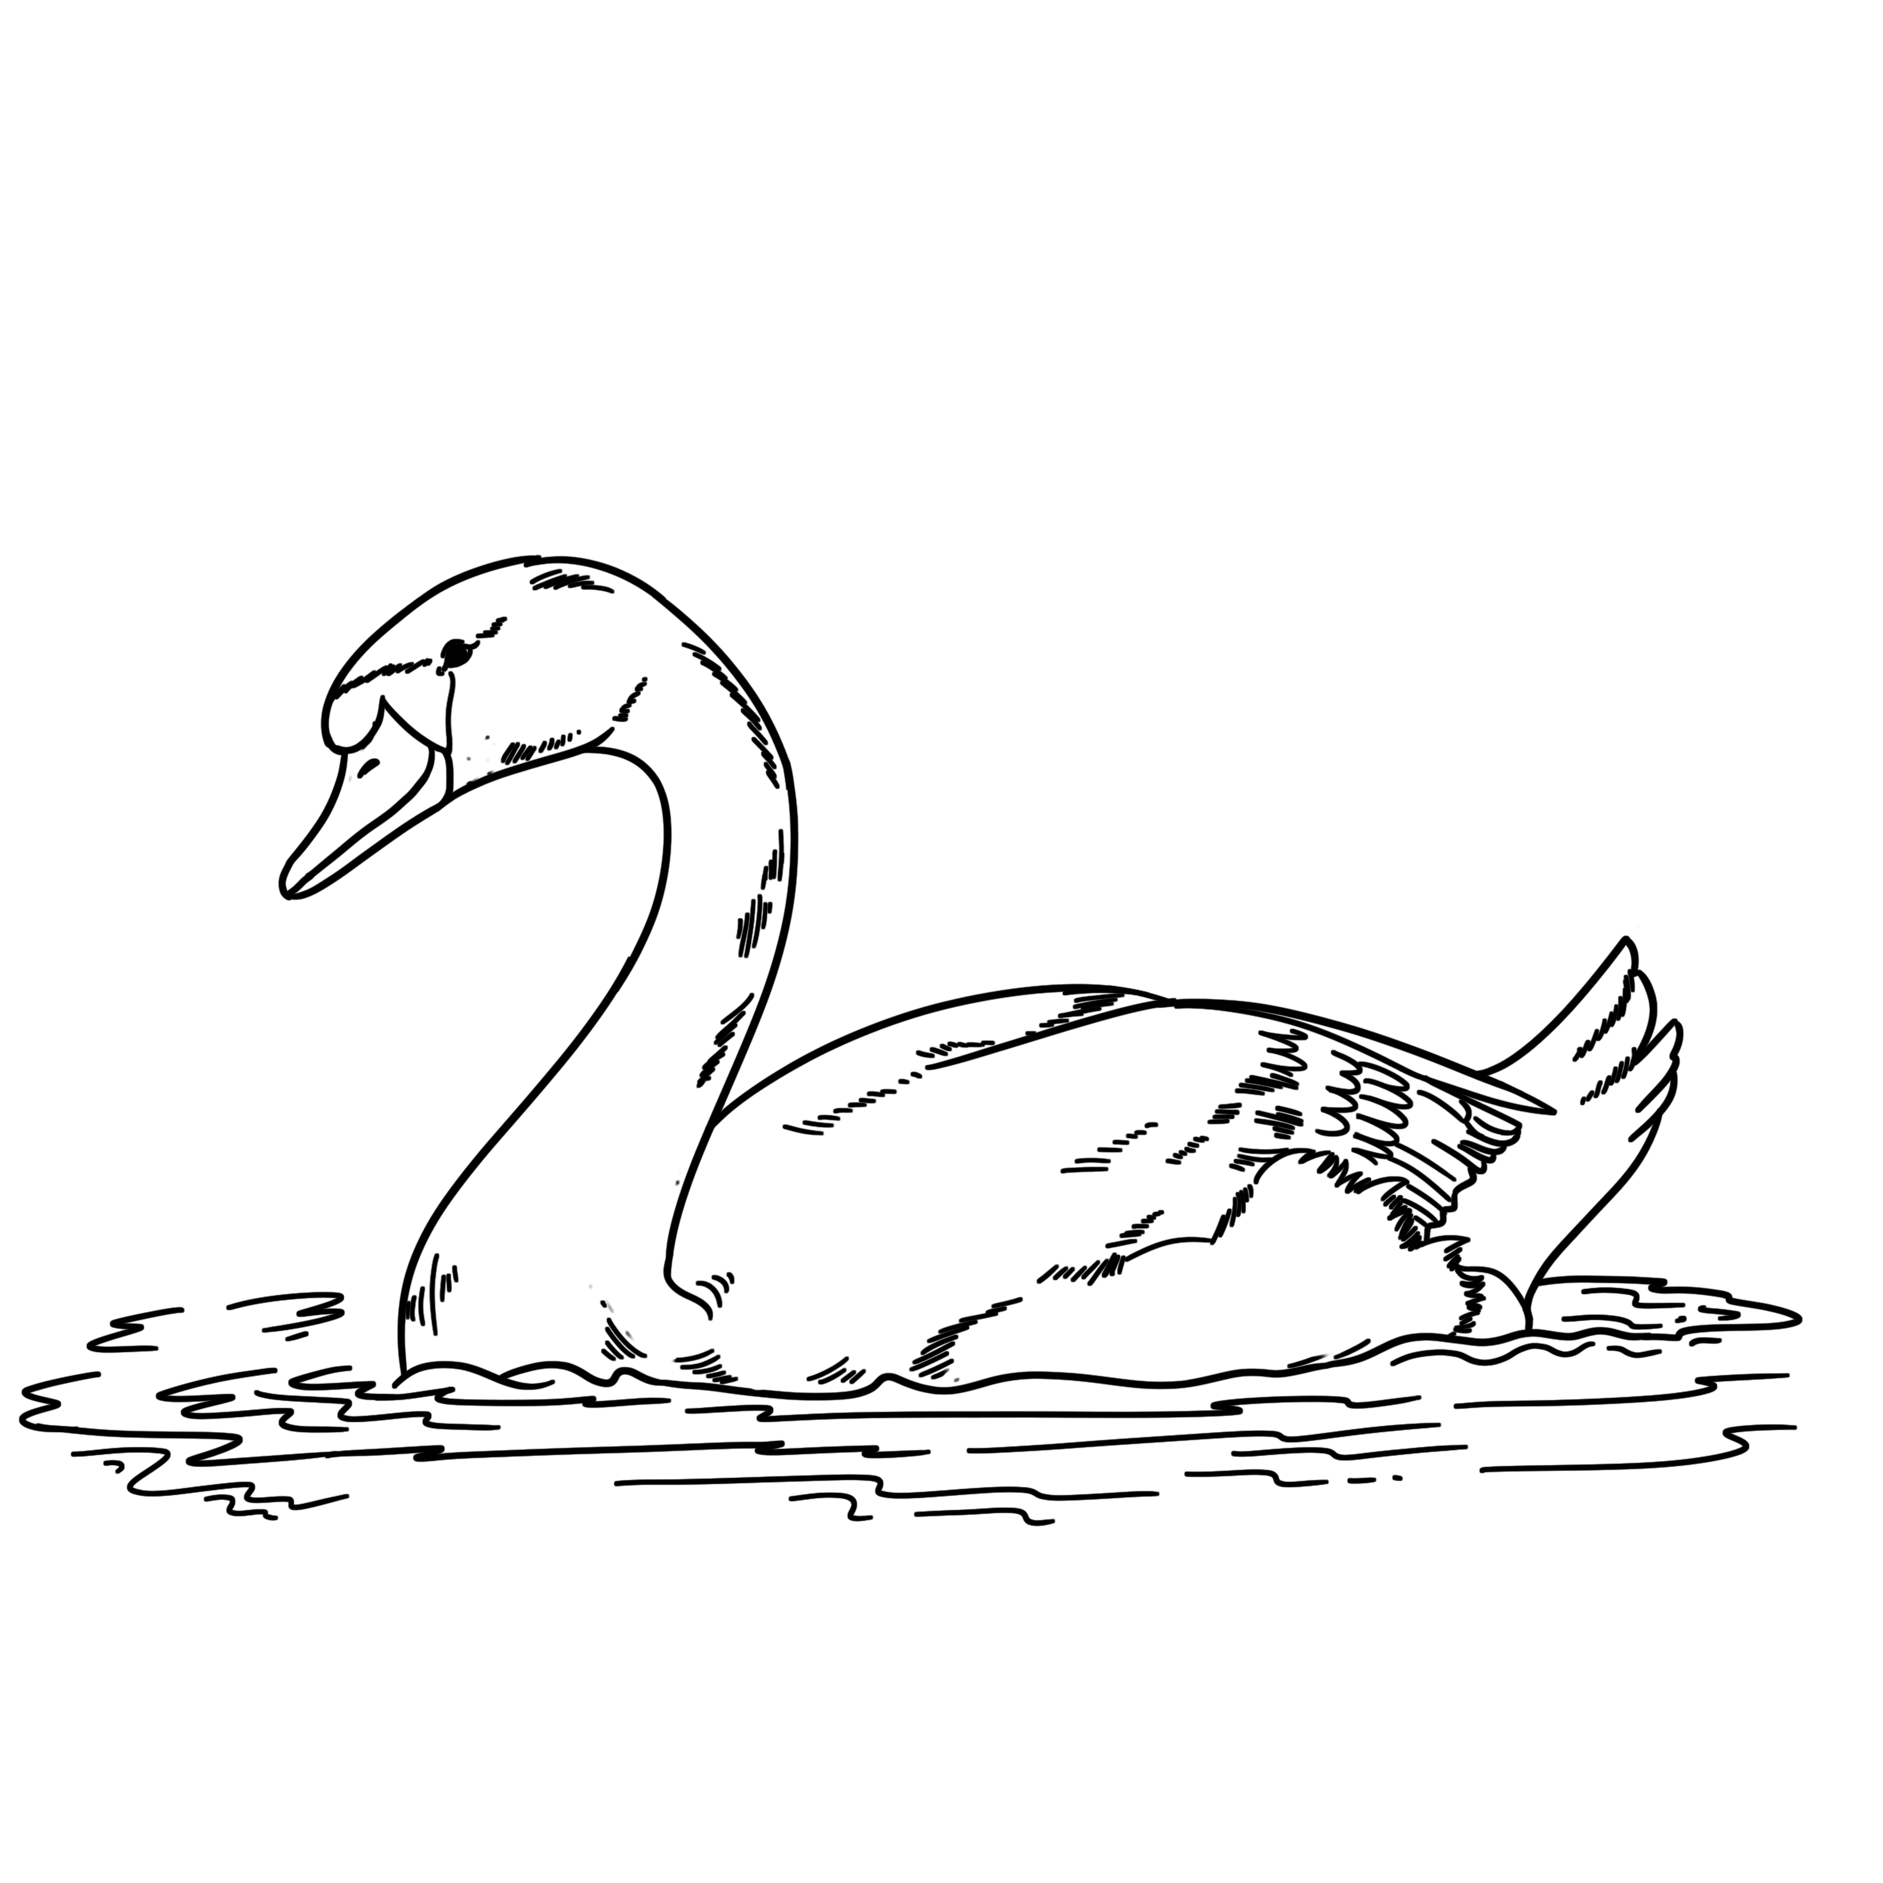
28 | owl |  |  | I | 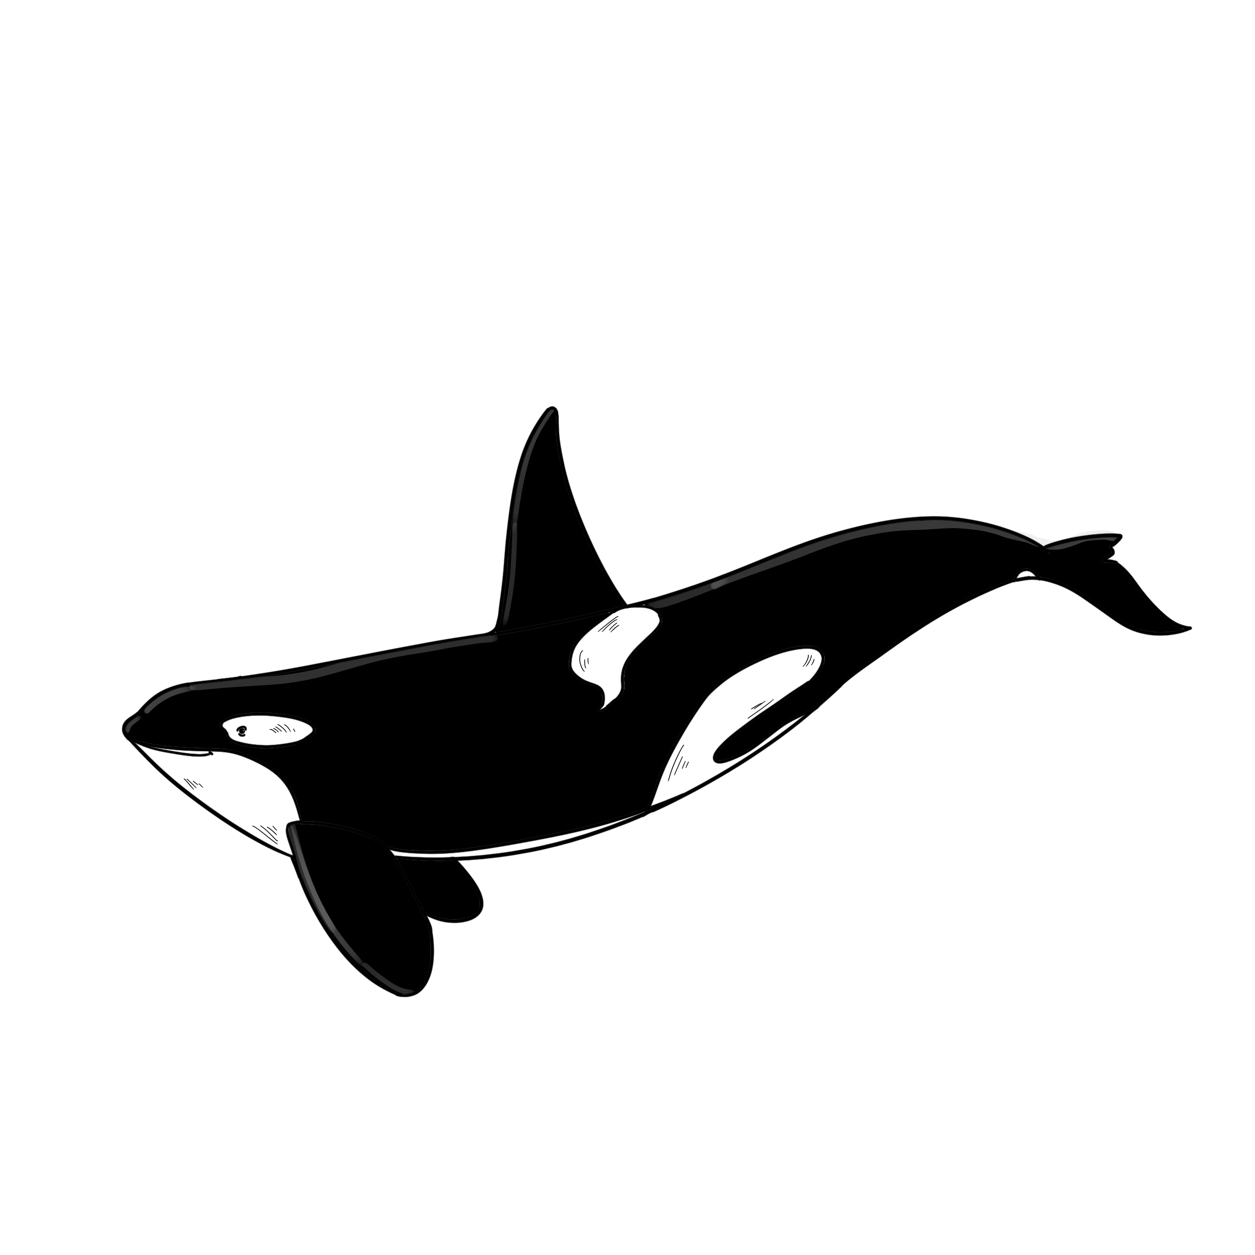
29 | wolf |  |  | J | 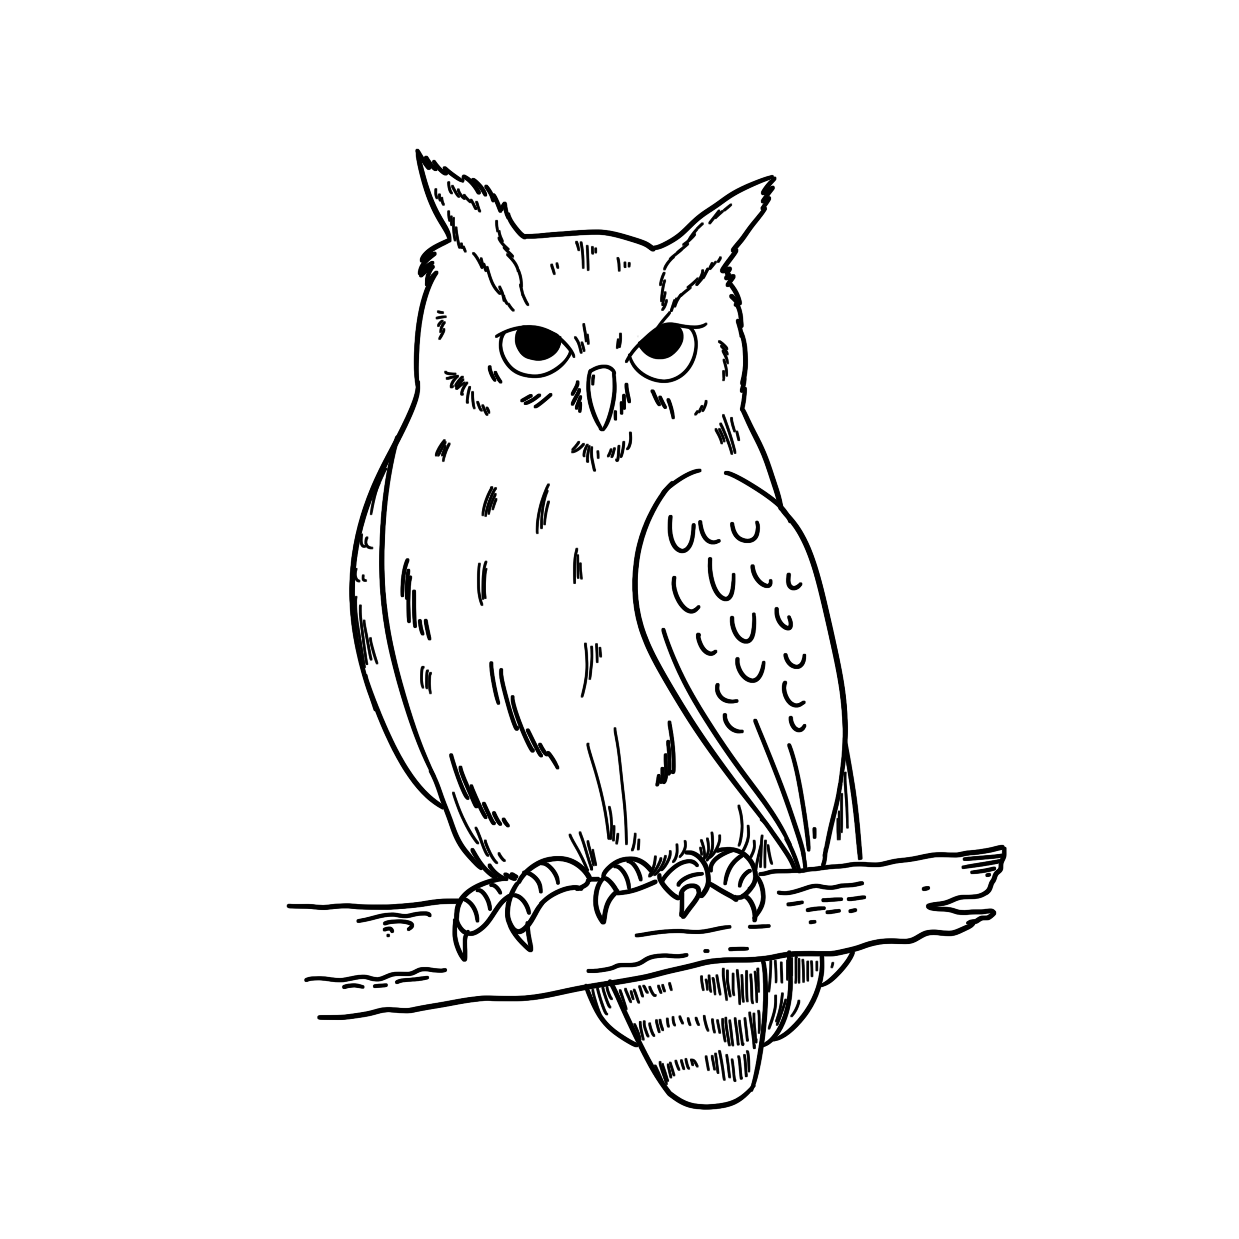
30 | swan |  |  | K | 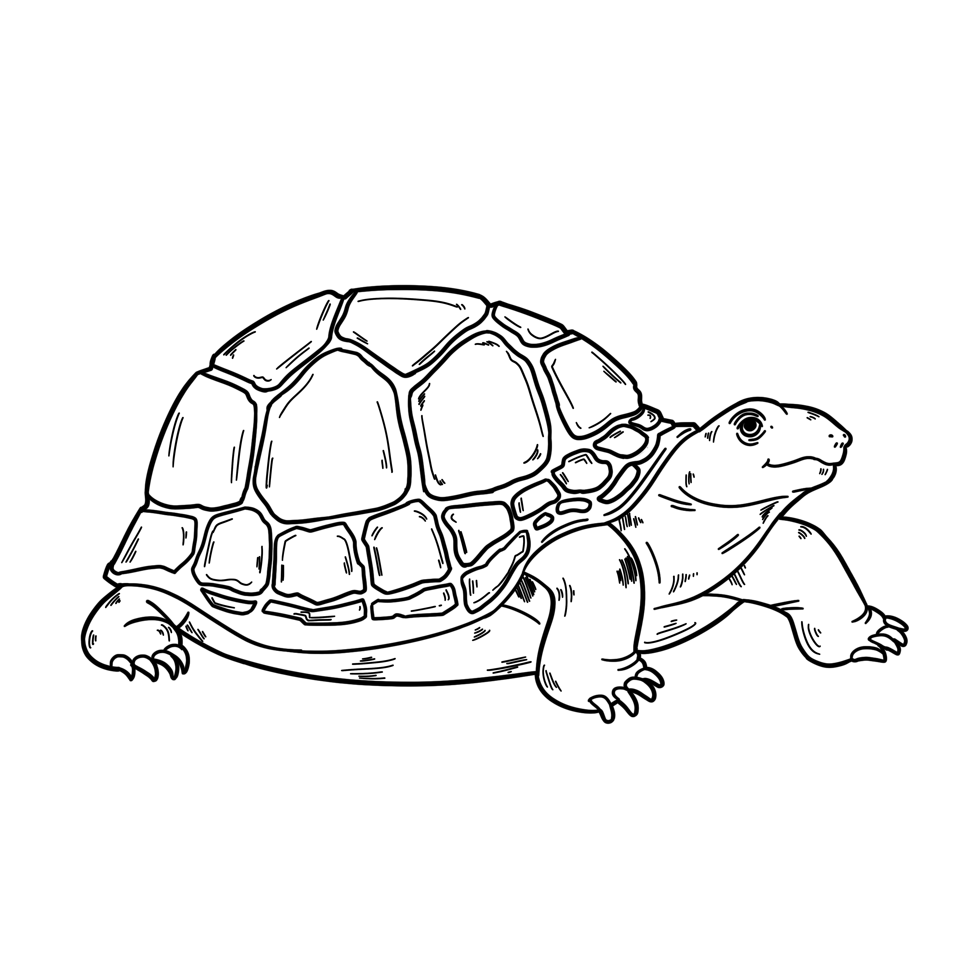
[Total: 10 marks]

Grammar 3
Complete the sentences by making comparative adverbs using the adjectives in brackets.
Example:
…………………..
- The horse was running much faster (much, fast) than usual when the accident happened.

- The leopard was travelling ………………….. (slightly, quick) than the antelope.

- The flooding was ………………….. (much, bad) than they thought at first.

- We need to protect animals ………………….. (far, careful) than we do now.

- Most fish swim ………………….. (much, slow) sharks.

- The plan to save the birds worked ………………….. (far, good) they expected.

[Total: 5 marks]

Grammar 4
Complete the multi-word verbs using the correct preposition.
Example:
………….
- The teachers always tell us off if we talk too much in class.

- I’m not getting ………. well with one of my friends at the moment.
- I could do ……… a rest – I’m feeling really tired!
- I’ve got ……… the habit of going for a walk after dinner.
- I’m finding it hard to keep ……… with all the homework I’m getting.
- I saw someone famous today and went up ……… them and asked for a selfie!

[Total: 5 marks]

